Solution to every third end-of-chapter problem
Basics of Engineering Economy, 2nd edition
Leland Blank and Anthony Tarquin

Chapter 2
Factors: How Time and Interest Affect Money

2.1 (a) (F/P,10%,20) = 6.7275
(b) (A/F,4%,8) = 0.10853
- (P/A,8%,20) = 9.8181
- (A/P,20%,28) = 0.20122
- (F/A,30%,15) = 167.2863

2.4 (a) F = 885,000 + 100,000(F/P,10%,3)
= 885,000 + 100,000(1.3310)
= $1,018,000

(b) Spreadsheet function is = -FV(10%,3,,100000) + 885000
Display is $1,018,000

2.7 (a) F = 3000(F/P,10%,12) + 5000(F/P,10%,8)
= 3000(3.1384) + 5000(2.1436)
= $20,133.20

(b) Sum two calculator functions
FV(10,12,,-3000) + FV(10,8,-5000)
9,415.29 + 10,717.94 = $20,133.23

(c) If the spreadsheet function is = – FV(10%,12,,3000) – FV(10%,8,,5000), the
display is $20,133.23

2.10 A = 12,700,000(A/P,20%,8)
= 12,700,000(0.26061)
= $3,309,747

2.13 A = 20,000,000(A/P,10%,6)
= 20,000,000(0.22961)
= $4,592,200

2.16 (a) A = 3,000,000(10)(A/P,8%,10)
= 30,000,000(0.14903)
= $4,470,900

(b) If calculator function is PMT(8,10,-30000000,0), the answer is $4,470,884.66

(c) If the spreadsheet function is = -PMT(8%,10,30000000), display is
A = $4,470,884.66
2.19 (a) A = 225,000(A/P,15%,4)
= 225,000(0.35027)
= $78,811

(b) Recall amount = 78,811/0.10
= $788,110 per year

2.22 P = (280,000-90,000)(P/A,10%,5)
= 190,000(3.7908)
= $720,252

2.25 P = 2,100,000(P/F,10%,2)
= 2,100,000(0.8264)
= $1,735,440

2.28 P = 95,000,000(P/F,12%,3)
= 95,000,000(0.7118)
= $67,621,000

2.31 (a) P = 7000(P/F,10%,2) + 9000(P/F,10%,4) + 15,000(P/F,10%,5)
= 7000(0.8264) + 9000(0.6830) + 15,000(0.6209)
= $21,245.30

(b) Three calculator functions are added.

-PV(10,2,0,7000) – PV(10,4,0,9000) – PV(10,5,0,15000)
Total is 5785.12 + 6147.12 + 9313,82 = $21,246.06

2.34 A = 10,000,000(A/P,10%,10)
= 10,000,000(0.16275)
= $1,627,500

2.37 A = 3,250,000(A/P,15%,6)
= 3,250,000(0.26424)
= $858,780

2.40 A = 5000(7)(A/P,10%,10)
= 35,000(0.16275)
= $5696.25

2.43 (a) Let CF₄ be the amount in year 4
100,000(F/P,9%,3) + 75,000(F/P,9%,2) + CF₄(F/P,9%,1) = 290,000
100,000(1.2950) + 75,000(1.1881) + CF₄(1.0900) = 290,000
(1.09)CF₄ = 71.392.50
CF₄ = $65,497.71
(b) F in year 5 for 2 known amounts
= -FV(9%,3,0,100000) - FV(9%,2,0,75000)

P in year 4 of $290,000 minus amount above (assume it’s in cell H9)
= -PV(9%,1,0,290000-H9)

Answer is $65,495.05

2.46 F = P(F/P,10%,n)
3P = P(F/P,10%,n)
(F/P,10%,n) = 3.000

From 10% interest tables, n is between 11 and 12 years. Therefore, n = 12 years

2.49 (a) P = 26,000(P/A,10%,5) + 2000(P/G,10%,5)
= 26,000(3.7908) + 2000(6.8618)
= $112,284

(b) Spreadsheet: enter each annual cost in adjacent cells and use the NPV
function to display P = $112,284

Calculators have no function for gradients; use the PV function on each cash
flow and add the five P values to get $112,284.55

2.52 A = 9000 – 560(A/G,10%,5)
= 9000 – 560(1.8101)
= $7986

2.55 A = 100,000 + 10,000(A/G,10%,5)
= 100,000 + 10,000(1.8101)
= $118,101

F = 118,101(F/A,10%,5)
= 118,101(6.1051)
= $721,018

2.58 475,000 = 25,000(P/A,10%,6) + G(P/G,10%,6)
475,000 = 25,000(4.3553) + G(9.6842)
9.6842G = 366,117.50
G = $37,805.65

2.61 A = 7,000,000 - 500,000(A/G,10%,5)
= 7,000,000 - 500,000(1.8101)
= $6,094,950

2.64 P = (23,000) 1 – (1.02/1.10)⁵
(0.10 – 0.02)
= $90,405

2.67 First find P and then convert to A. (in million-people units)

P = 15,000(10)[1 – (1.15/1.08)⁵]/(0.08 – 0.15)
= $790,491,225,000

A = 790,491,225,000(A/P,8%,5)
= 790,491,225,000(0.25046)
= $197.986 billion (spreadsheet answer is $197,983,629,604)

2.70 Solve for P in geometric gradient equation and then convert to A
A₁ = 5,000,000(0.01) = 50,000

P = 50,000[1 – (1.10/1.08)⁵]/(0.08 – 0.10)
= $240,215

A = 240,215(A/P,8%,5)
= 240,215(0.25046)
= $60,164

2.73 Solve for A₁ in geometric gradient equation and then find cost in year 3

400,000 = A₁[1 – (1.04/1.10)⁵]/(0.10 – 0.04)
4.0759 A₁ = 400,000
A₁ = $98,138

Cost in year 3 = 98,138(1.04)²
= $106,146

2.76 Since 4th deposit is known to be $1250, increase it by 5% each year to year one

A₁ = 1250/(0.95)³
= $1457.94

2.79 F = 200,000(F/A,10%,6)
= 200,000(7.7156)
= $1,543,120

2.82 F in year 8 = 100(F/A,10%,3)(F/P,10%,6) + 200(F/A,10%,4)(F/P,10%,2)
= 100(3.3100)(1.7716) + 200(4.6410)(1.21)
= $1709.52

2.85 Find the future worth F_{paid} of 3 payments in year 4

F_{paid} = 2,000,000(F/A,8%,3)(F/P,8%,1)
= 2,000,000(3.2464)(1.08)
= $7,012,224

Find total amount owed F_{owed} after 4 years
F_{owed} = 10,000,000(F/P,8%,4)
= 10,000,000(1.3605)
= $13,606,000

Due in year 4 = 13,606,000 - 7,012,224
= $6,593,776

2.88 Find P in year 0 then convert to F. In $ million units,

P₀ = 450 – 40(P/F,10%,1) + 200(P/A,10%,6)(P/F,10%,1)
= 450 – 40(0.9091) + 200(4.3553)(0.9091)
= $1205.52

F₇ = 1205.52(F/P,10%,7)
= 1205.52(1.9487)
= $2349.20

2.91 Factors: (a) P = 31,000(P/A,8%,3) + 20,000(P/A,8%,5)(P/F,8%,3)
= 31,000(2.5771) + 20,000(3.9927)(0.7938)
= $143,278

(b) A = 143,278(A/P,8%,8)
= 143,278(0.17401)
= $24,932
Spreadsheet:
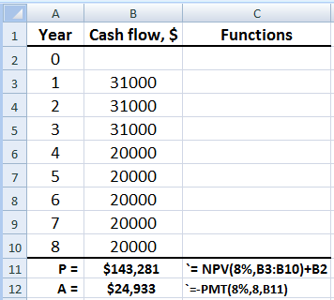

2.94 In $ billion units,

Gross revenue first 2 years = 5.8(0.701) = $4.0658
Gross revenue last 2 years = 6.2(0.701) = $4.3462

F = 4.0658(F/A,14%,2)(F/P,14%,2) + 4.3462(F/A,14%,2)
= 4.0658(2.1400)(1.2996) + 4.3462(2.1400)
= $20.6084 billion

2.97 First find F in year 8 and then solve for A

F₈ = 15,000(F/A,8%,7) + 10,000(F/A,8%,4)
= 15,000(8.9228) + 10,000(4.5061)
= $178,903

A = 178,903(A/F,8%,8)
= 178,903(0.09401)
= $16,819

2.100 Find P in year -1for geometric gradient, than move to year 0 to find P
P₋₁ = (30,000) 1 – (1.05/1.10)⁸
(0.10 – 0.05)
= $186,454

F = P₀ = 186,454(F/P,10%,1)
= 186,454(1.10)
= $205,099

2.103 Find P in year –6 using arithmetic gradient factor and then find F today

P₋₆ = 10,000(P/A,12%,6) + 1000(P/G,12%,6)
= 10,000(4.1114) + 1000(8.9302)
= 41,114 + 8930.20
= $50,044.20

F = 50,044.20(F/P,12%,6)
= 122,439(1.9738)
= $98,777

2.106 (a) Add and subtract $2400 and $2600 in periods 3 and 4, respectively, to use
gradient

30,000 = 2000 + 200(A/G,10%,8) – 2400(P/F,10%,3)(A/P,10%,8)
-2600(P/F,10%,4)(A/P,10%,8) + x(P/F,10%,3)(A/P,10%,8)
+ 2x(P/F,10%,4)(A/P,10%,8)

30,000 = 2000 + 200(3.0045) – 2400(0.7513)( 0.18744)
-2600(0.6830)( 0.18744) + x(0.7513)(0.18744)
+ 2x(0.6830)( 0.18744)

30,000 = 2000 + 600.90 – 337.98 – 332.86 + 0.14082x + 0.25604x
0.39686x = 28,069.94
x = $70,730

(b) Spreadsheet uses Goal Seek to find x = $70,726

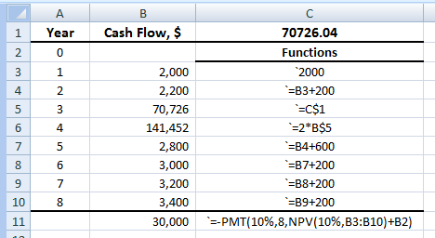
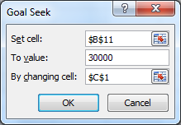

2.109 (a) Find P in year 4 for the geometric gradient, (b) Spreadsheet
then move all cash flows to future
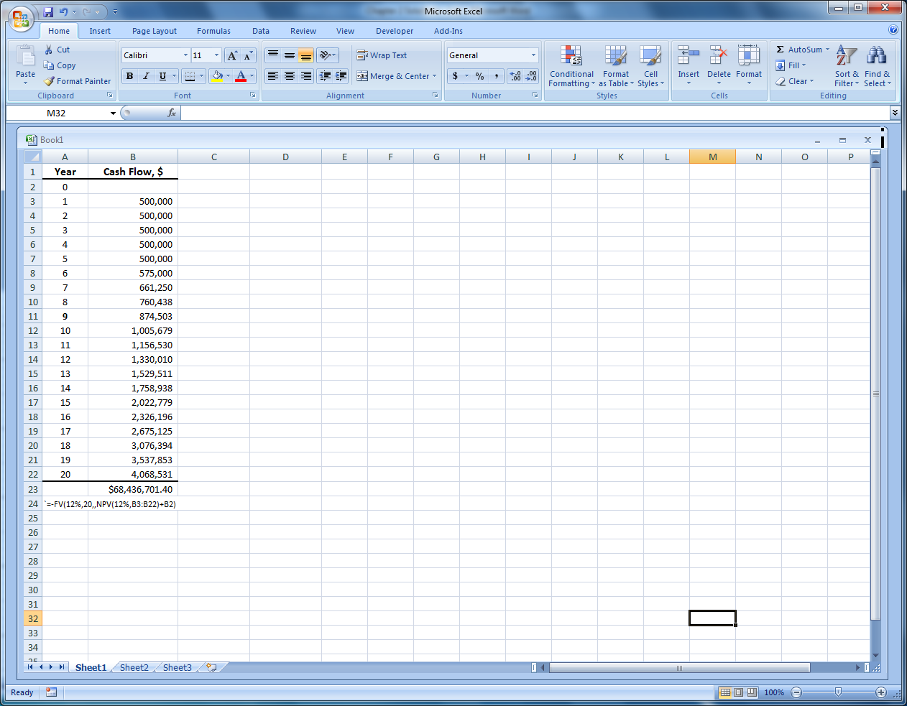

P₄ = 500,000[1 – (1.15/1.12)¹⁶]/(0.12 – 0.15)
= $8,773,844

F = 500,000(F/A,12%,4)(F/P,12%,16) + P₄(F/P,12%,16)
= 500,000(4.7793)(6.1304) + 8,773,844(6.1304)
= $68,436,684

2.112 Answer is (a)

2.115 A = 10,000,000((A/P,15%,7)
= $2,403,600

Answer is (a)

2.118 F = 50,000(F/P,18%,7)
= 50,000(3.1855)
= $159,275

Answer is (b)

2.121 10,000 = 2x(P/F,10%,2) + x(P/F,10%,4)
10,000 = 2x(0.8264) + x(0.6830)
2.3358x = 10,000
x = $4281

Answer is (a)

2.124 1000(F/P,10%,20) + 1000(F/P,10%,n) = 8870
1000(6.7275) + 1000(F/P,10%,n) = 8870
1000(F/P,10%,n) = 2142.5
(F/P,10%,n) = 2.1425
n = 8

Deposit year = 20 - 8 = 12

Answer is (d)

